**Question 1:**

Create a program that checks if a person is eligible to vote based on their age and citizenship status.

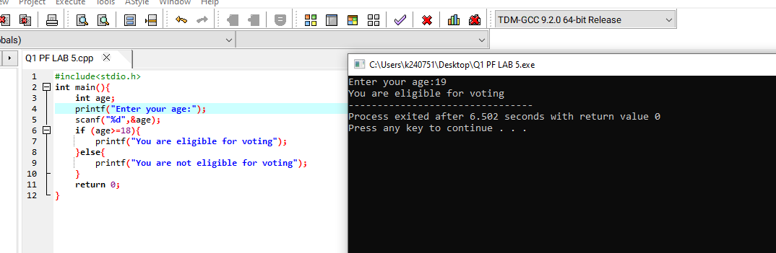

**Question 2:**

Check if a triangle is valid based on its three angles, where the sum must be exactly 180 degrees and all angles must be positive.

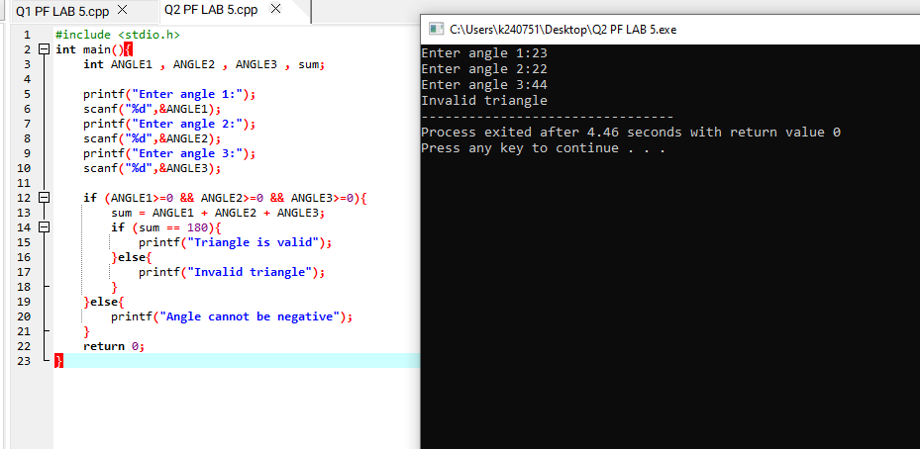

**Question 3:**

Write a C program that uses the ternary operator to determine the letter grade of a student based on their percentage. The grading scale is as follows:

A. for percentages 90 and above B. for percentages 80 to 89

C. for percentages 70 to 79 D . for percentages 60 to 69

F. for percentages below 60

